Mr Paul Bennett  General Manager  Tamworth Regional Council  PO Box 555  TAMWORTH NSW 2340 | Our ref: EF 18/47761  Your ref: la/GH/SF9035
Att: Genevieve Harrison
12/05/2020

Dear Mr Bennett
Subject: Planning Proposal PP_2018_TAMWO_005_00 - to prohibit caravan parks in the RE2 Private Recreation zone, rezone Lot 2 DP 864981, Greg Norman Drive, Hillvue, from SP3 Tourist to RE2 Private Recreation and Lot 1 & 2 DP 1055796, Kennedy Street, Manilla, from RE2 Private Recreation to RE1 Public Recreation
I refer to your letter of 7 May 2020 requesting permission to commence exhibition of the above Planning Proposal.
The Gateway determination for the above Planning Proposal issued on 11 December 2019 required that the proposal document be amended prior to exhibition to address those matters outlined in condition 1 of the Gateway. The Planning Proposal submitted with Council’s request appears to of satisfied this requirement and may now be exhibited in accordance with the relevant conditions of the Gateway determination.
Should you have any further enquiries relating to this Planning Proposal, please don’t hesitate to contact me on the 5778 1487.
Yours sincerely
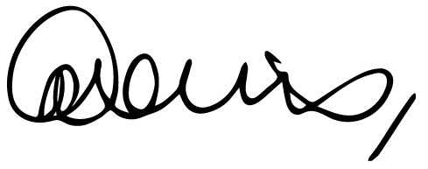
Gina Davis
Senior Planner, Northern Region

